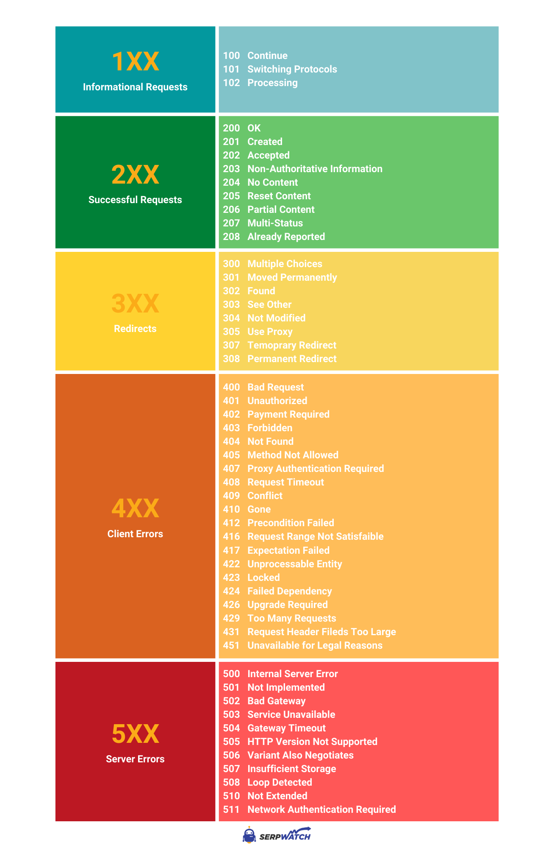

**Formatter**

Formatterler cox vaxt usere gostermek ucun deyisdiriler biler.

Input and output formatters are tools or components used in software development to transform data between different formats.

An input formatter takes input data in one format and converts it into a format that can be processed by the application or system. This can involve parsing text, decoding binary data, or extracting relevant information from a complex data structure. The output of the input formatter is typically a standardized format that the application can work with.

On the other hand, an output formatter takes processed data from the application and converts it into a desired output format. This could involve formatting the data as plain text, encoding it in a specific binary format, or generating output in a structured format like JSON or XML. The output formatter ensures that the data is presented in a way that is useful and meaningful to the recipient or the next step in the data processing pipeline.

Input and output formatters play a crucial role in data integration, data exchange, and interoperability between different systems or components. They help ensure compatibility and consistency when working with diverse data formats and enable seamless communication and data flow between different software components.